ASSISTANCE TO INDIVIDUAL IN CRISIS SITUATION
MEDICAL ASSISTANCE
April 16, 2026

DR. DIGNA RAGASA
Hospital Administrator
Metro Vigan Hospital
Bantay, Ilocos Sur

Ma’am:

The undersigned would like to ask for your favorable assistance to Jovelyn Quindoyos, 53 years old of Barangay Purok-A-Bassit, Vigan City who was examined thereat.

In this regard, may I request you to deduct the amount of THREE THOUSAND PESOS ONLY (P3,0000.00) from the payment of her series of 2D Echo with Doppler chargeable to Assistance to Individual in Crisis Situation Program of the City Government.

Truly yours,
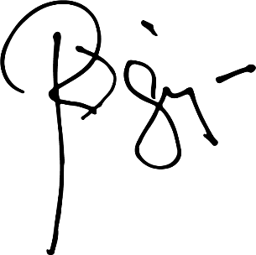

HON. RANDOLF “RANDY” V. SINGSON

Control No.055M-2026

CERTIFICATION

This is to certify that to Jovelyn Quindoyos, 53 years old of Barangay Purok-A-Bassit, Vigan City, Ilocos Sur who was examined by the hospital. The said patient consumed the amount THREE THOUSAND PESOS ONLY (P3,0000.00) for the service guaranteed for payment by the City Government of Vigan.

Conforme:

JOVELYN QUINDOYOS _____________________
Client Signature over Printed Name
(Representative of the Hospital)

Control No. 055M-2026

